- Data Cleaning & Modeling:

Fix missing fuel consumption values (use avg. per vehicle type).
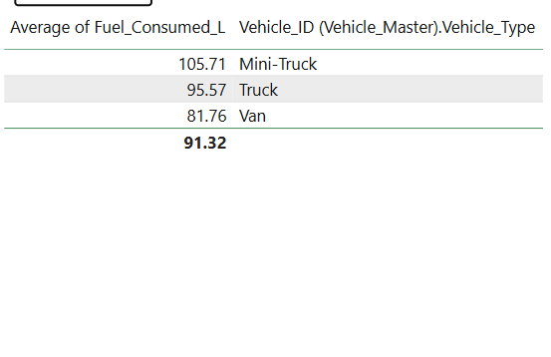

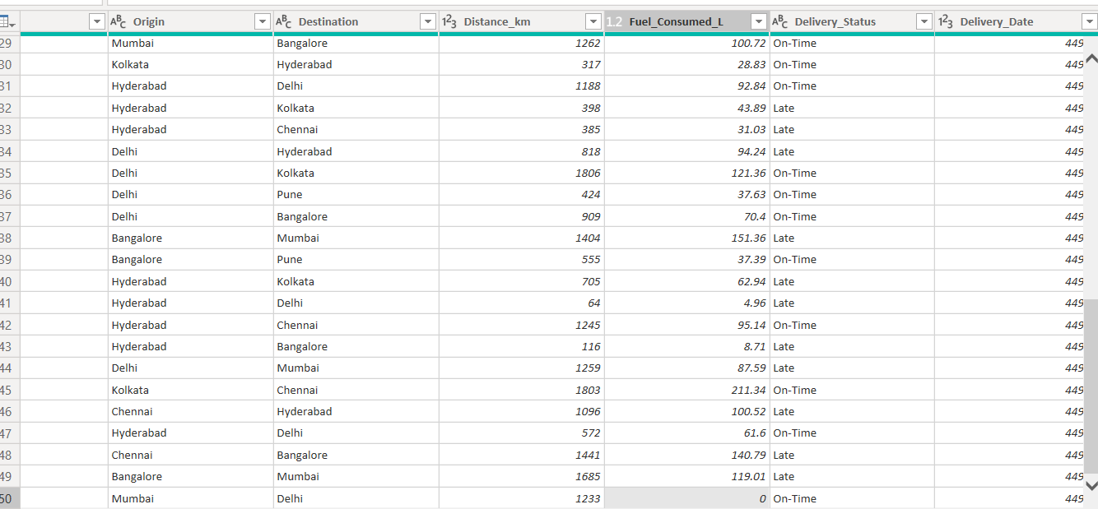

Replace null value with Calculated average

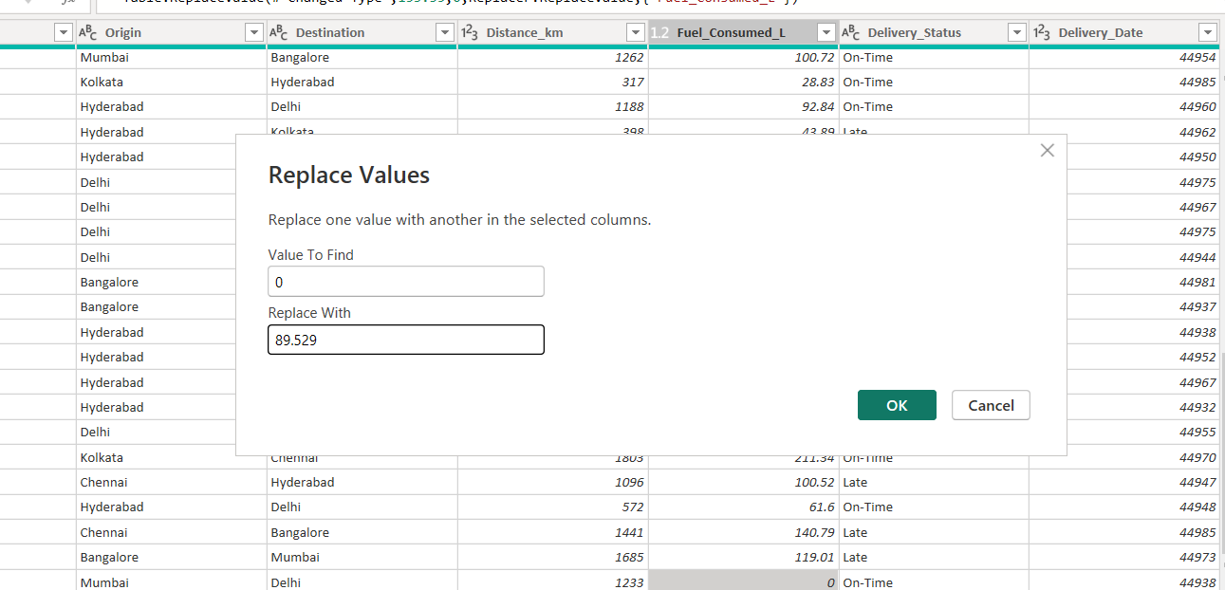

Relate Trips with Vehicle Master.

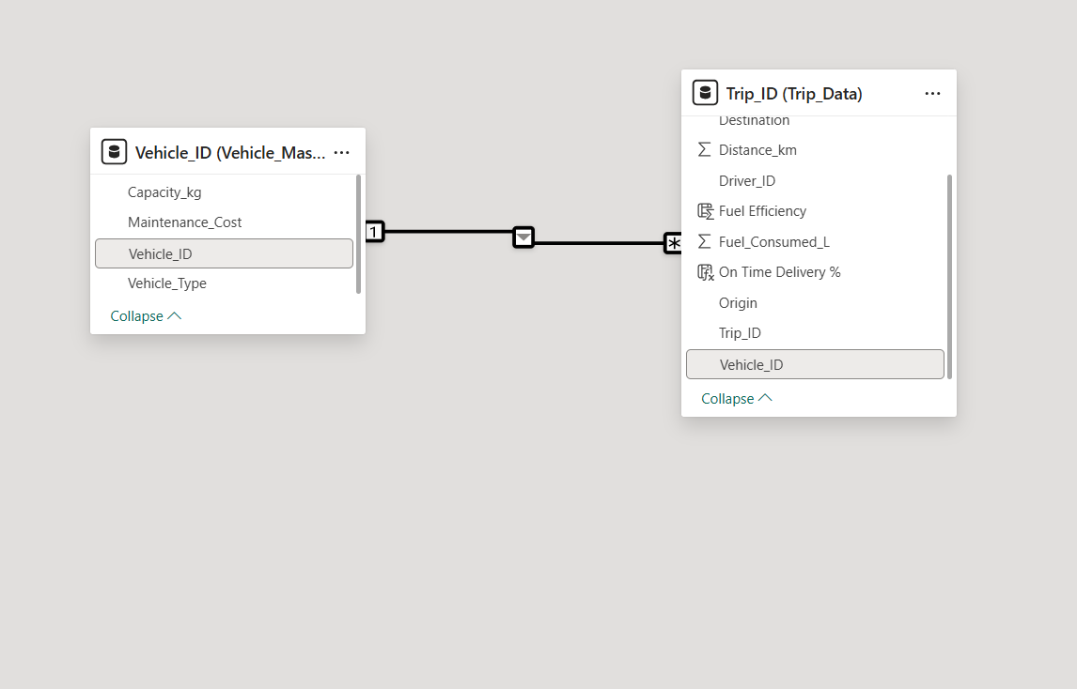

- DAX Measures:

Fuel Efficiency = Distance / Fuel Consumed

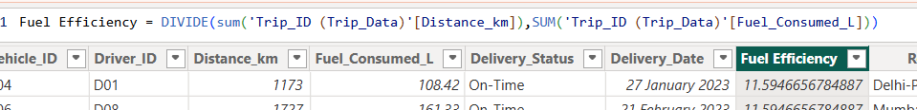

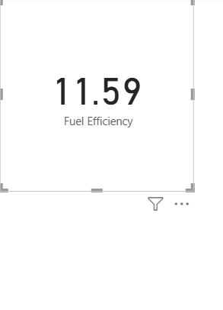
On-Time Delivery % = On-Time Trips / Total Trips

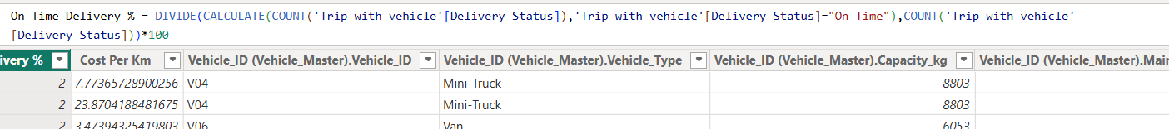
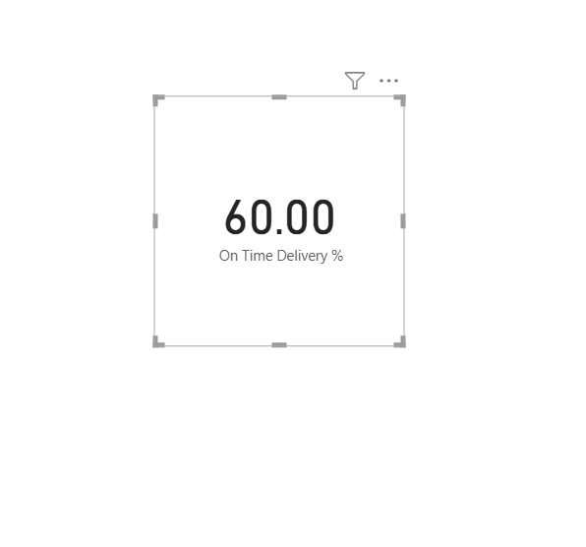

Cost per km = (Fuel Cost + Maintenance Cost) / Distance

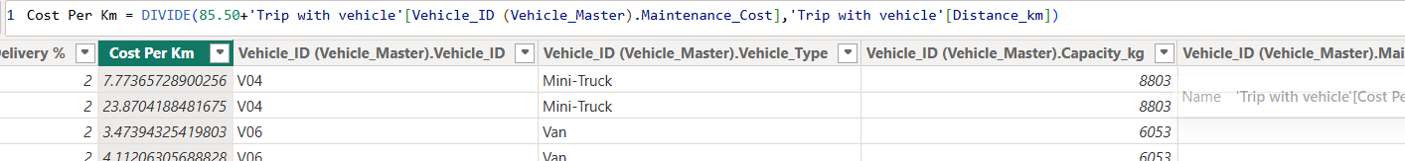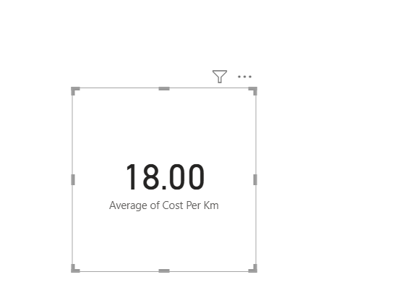

- Visualization:
Bar chart: On-Time Delivery % by Route.

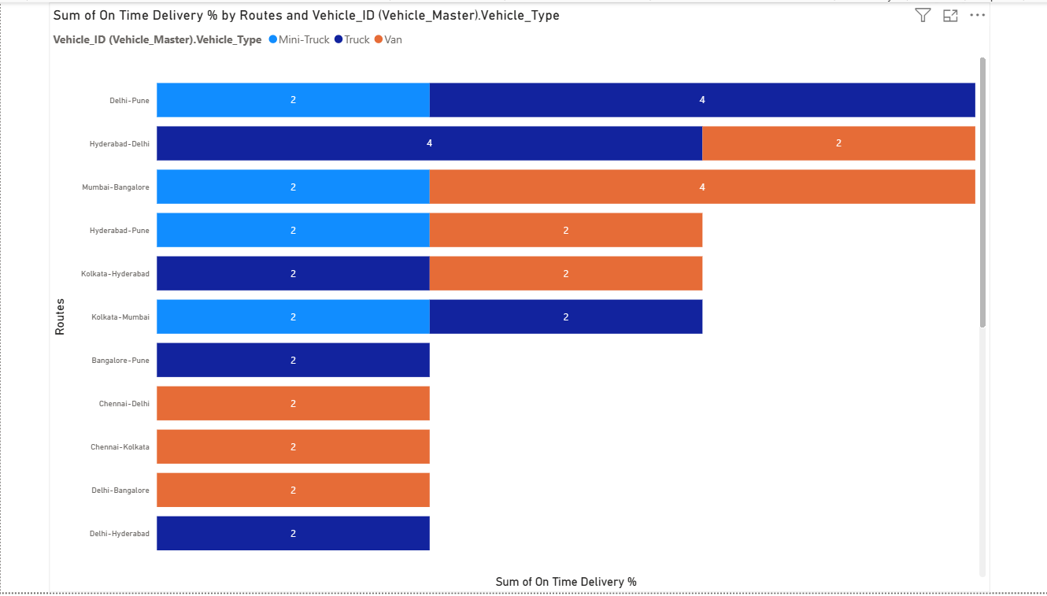

Line chart: Fuel Efficiency trend by month.

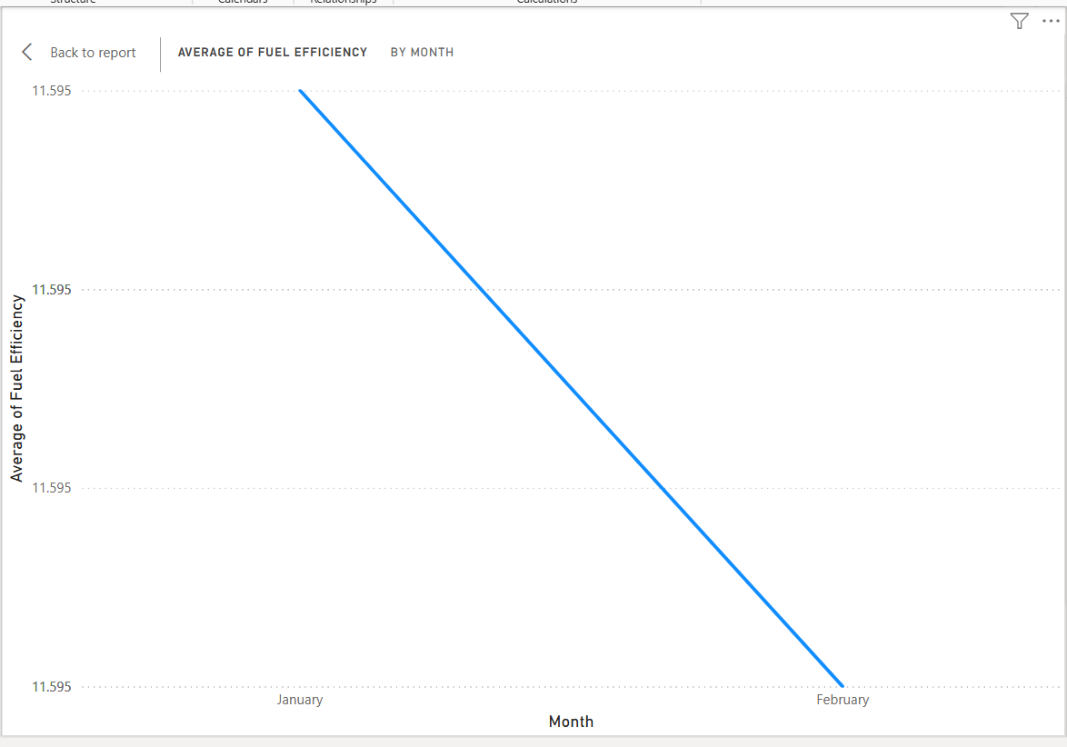

Cards: Avg. Delivery Time, Cost per km.

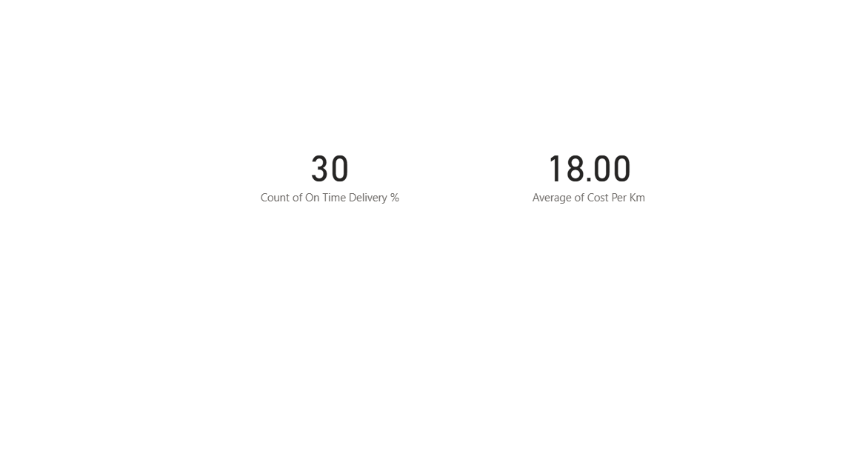

Map visual: Delivery performance by route (Origin → Destination).

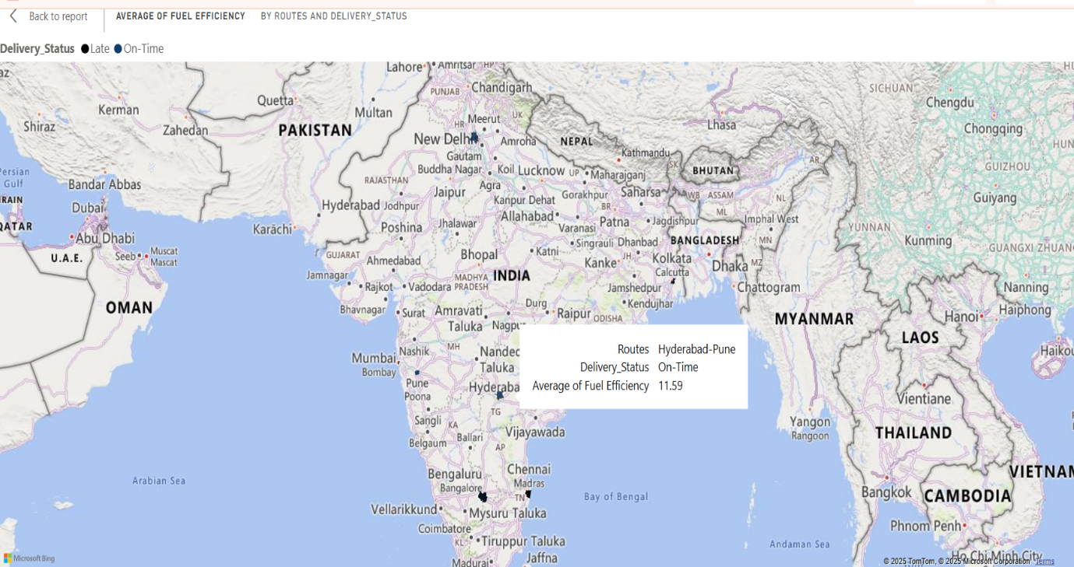

Expected Output: A transport operations dashboard to optimize routes and fleet usage

